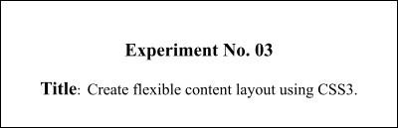

# Batch:B2 Roll No.: 16010421119 Experiment No.: 3

**Aim**: To apply basic CSS and flexible content layout using CSS3 to your website..

**Resources needed:** need to fill by students

**Theory:**

**Cascading Style Sheets** (**CSS**) is a style sheet language used for describing the presentation of a document written in a markup language.HTML was NEVER intended to contain tags for formatting a web page.HTML was created to **describe the content** of a web page. CSS is designed primarily to enable the separation of document content from document presentation, including aspects such as the layout, colors, and fonts. This separation can improve content accessibility, provide more flexibility and control in the specification of presentation characteristics, enable multiple HTML pages to share formatting by specifying the relevant CSS in a separate .css file, and reduce complexity and repetition in the structural content. The file should not contain any html tags. The style sheet file must be saved with a .css extension.

CSS has various levels and profiles like CSS1, CSS2, CSS3, CSS4.

There are three ways of inserting a style sheet:

∙ External style sheet

∙ Internal style sheet

∙ Inline style

# External Style Sheet

Each page must include a reference to the external style sheet file inside the <link> element. The <link> element goes inside the <head> section of html page. An external style sheet is ideal when the style is applied to many pages.

# Internal Style Sheet

An internal style sheet may be used if one single page has a unique style.Internal styles are defined within the <style> element, inside the<head> section of an HTML page

# Inline Styles

An inline style may be used to apply a unique style for a single element.To use inline styles, add the style attribute to the relevant element. The style attribute can contain any CSS property.

# CSS Rule-Set

A CSS rule-set consists of a selector and a declaration block:



Eg:-

p {

text-align: center; color: red;

}

Here p stands for paragraph element.

# CSS Colors and Backgrounds

Colors can be applied by using colors and background-color. Colors are displayed combining RED, GREEN, and BLUE light.The CSS background properties are used to define the background effects for elements.

**CSS Margin and Padding Properties.**

The CSS margin properties are used to generate space around elements. Margin is the space outside something whereas padding is the space inside something. The margin properties set the size of the white space OUTSIDE the border.The CSS padding properties are used to generate space around content.The padding properties set the size of the white space between the element content and the element border.

# CSS Dimension Properties

The CSS dimension properties allow you to control the height and width of an element.

# Navigation Bars

Having easy-to-use navigation is important for any web site.With CSS you can transform boring HTML menus into good-looking navigation bars.

# CSS Flexbox Layout

The Flexible Box Layout Module makes it easier to design flexible responsive layout structure without using float or positioning.

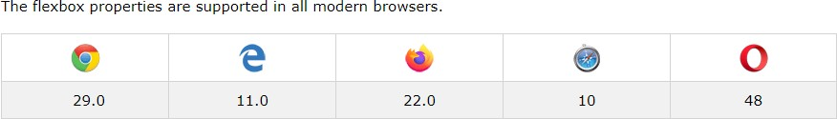

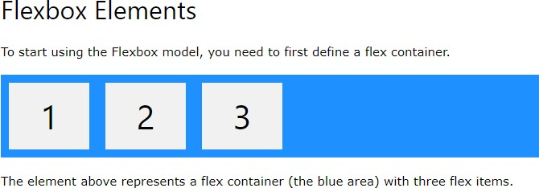

Example

<!DOCTYPE html>

<html>

<head>

<style>

.flex-container { display: flex; background-color: DodgerBlue;

}

.flex-container > div { background-color: #f1f1f1; margin: 10px; padding: 20px; font-size: 30px;

}

</style>

</head>

<body>

<div class="flex-container">

<div>1</div>

<div>2</div>

<div>3</div>

</div>

<p>A Flexible Layout must have a parent element with the <em>display</em> property set to <em>flex</em>.</p>

<p>Direct child elements(s) of the flexible container automatically becomes flexible items.</p>

</body>

</html>

Output

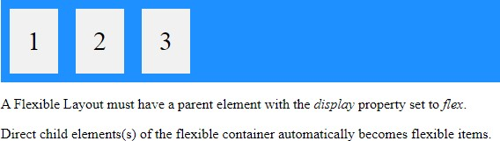

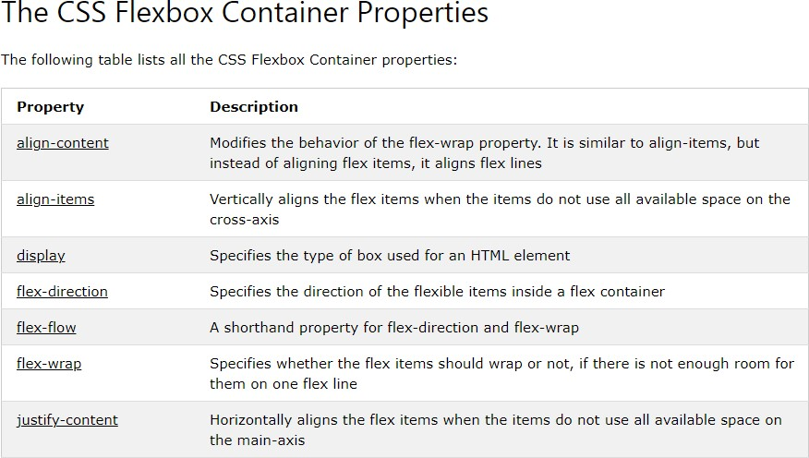

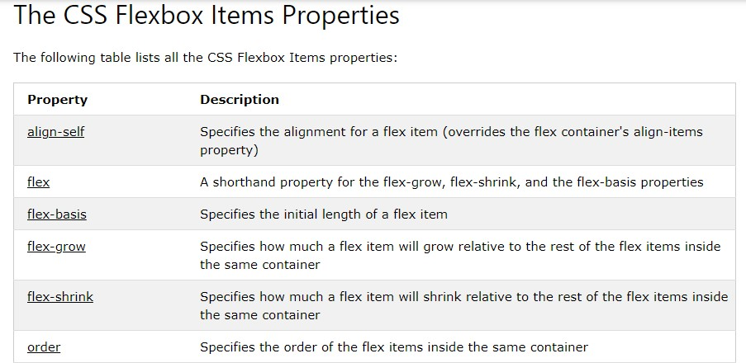

# Responsive Flexbox

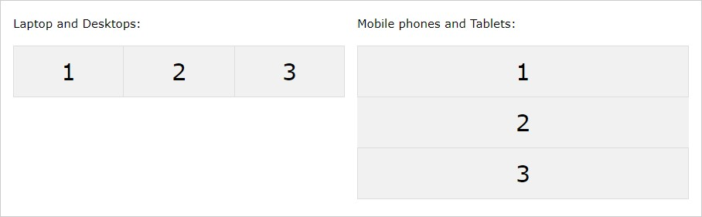

For example, if you want to create a two-column layout for most screen sizes, and a onecolumn layout for small screen sizes (such as phones and tablets), you can change the flexdirection from row to column at a specific breakpoint (800px in the example below.

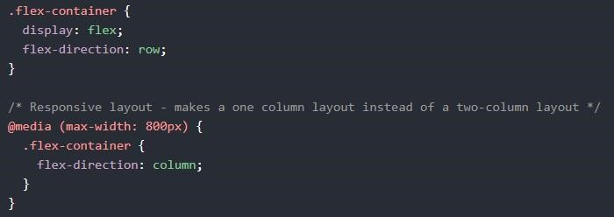

# CSS Grid Layout Module

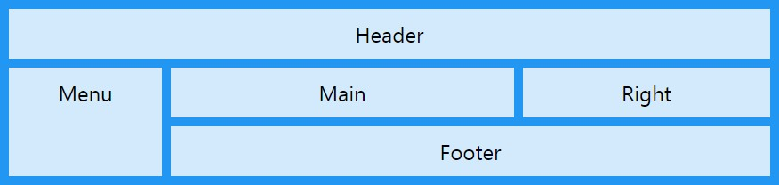

The CSS Grid Layout Module offers a grid-based layout system, with rows and columns, making it easier to design web pages without having to use floats and positioning.

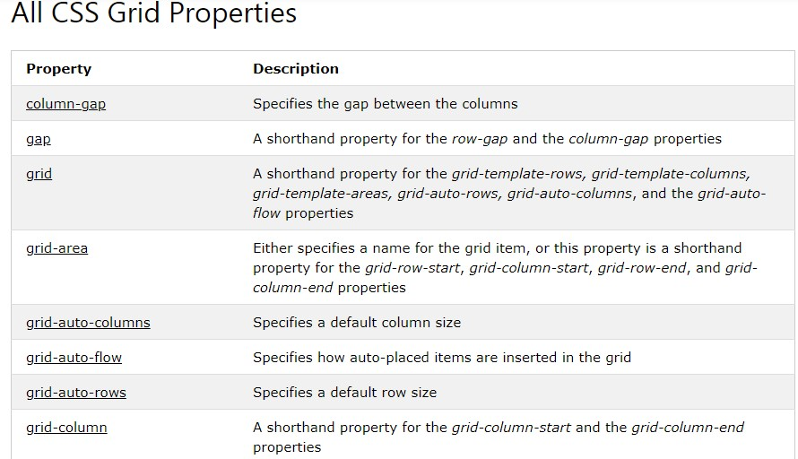

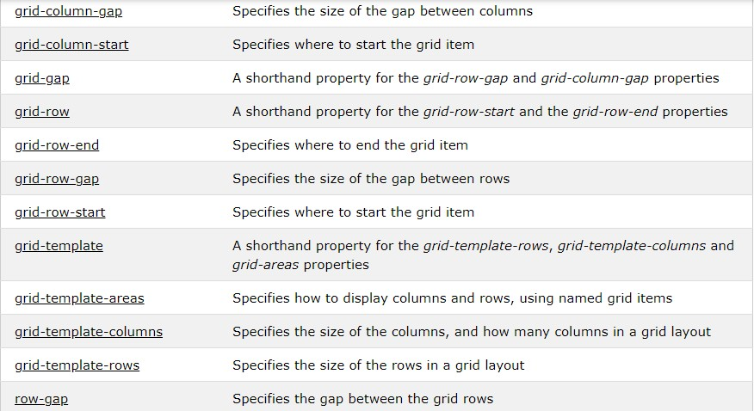

# Grid Container

To make an HTML element behave as a grid container, you have to set the display property to grid or inline-grid.

Grid containers consist of grid items, placed inside columns and rows.

**A grid container contains grid items.**

By default, a container has one grid item for each column, in each row, but you can style the grid items so that they will span multiple columns and/or rows.

**Activity:**

Design a website pages using CSS properties like Colors and Background-color,Lengths and percentages,Margin and padding,Borders,Navigation bars, flexbox layot, flexbox container and item properties, responsive flexbox ,CSS Grid ,Grid Container ,A grid container contains grid items.

# Results: Display the designed web pages along with the code

**HTML FILE:-**

<!DOCTYPE html>

<html lang="en">

<head>

<meta charset="UTF-8">

<meta http-equiv="X-UA-Compatible" content="IE=edge">

<meta name="viewport" content="width=device-width, initial-scale=1.0">

<link rel="stylesheet" href="https://fonts.googleapis.com/css?family=Julee">

<link rel="stylesheet" href="https://cdn.jsdelivr.net/npm/bootstrap-icons@1.10.3/font/bootstrap-icons.css">

<link rel="stylesheet" href="../css/home.css">

<title>Fitera - Home</title>

</head>

<!-- Navbar begins -->

<body>

<section id='navbar'>

<div class='navbar-section'>

<nav class='navbar-header'>

<ul class='navbar-list'>

<li id='navbar-item'>

<a href="#">Blog</a>

</li>

<li id='navbar-item'>

<a href="#">Features</a>

</li>

<li id='navbar-item'>

<a href="#">About Us</a>

</li>

<li id='navbar-item'>

<a href="#">Contact Us</a>

</li>

<li id='navbar-item'>

<a href="login.html">Log In/Signup</a>

</li>

</ul>

</nav>

</div>

</section>

<!-- Navbar ends -->

<!-- Banner begins -->

<section class='home'>

<div class='banner'>

<img src="../images/fitness_banner.png" alt="Banner" id='banner-img'>

<div class='banner-row'>

</div>

</div>

</section>

<!-- Banner ends -->

<!-- Footer begins -->

<section class='footer'>

<div class='social-media-link'>

<p id='social-media-text'>

Get connected with us on social media..

</p>

<ul id='social-media-list'>

<li>

<a href="https://www.instagram.com/">

<i class="bi bi-instagram" id='in'></i>

</a>

</li>

<li>

<a href="facebook.com">

<i class="bi bi-facebook" id='fb'></i>

</a>

</li>

<li>

<a href="linkedin.com">

id='ld' />

</a>

</li>

<li>

<a href="https://twitter.com/?lang=en-in">

<i class="bi bi-twitter" id='tw'></i>

</a>

</li>

<li>

<a href="tinder.com">

id='tn' />

</a>

</li>

</ul>

</div>

<div class='footer-links'>

<div class='row'>

<div class='column' id='c1'>

<span>Company name</span>

<p>

Here you can use rows and columns to organize your footer content. Lorem ipsum dolor sit amet, consectetur

adipisicing elit.

</p>

</div>

<div class='column' id='c2'>

<span>Products</span>

<p>

Here you can use rows and columns to organize your footer content. Lorem ipsum dolor sit amet, consectetur

adipisicing elit.

</p>

</div>

<div class='column' id='c3'>

<span>Useful Contact</span>

<p>

Here you can use rows and columns to organize your footer content. Lorem ipsum dolor sit amet, consectetur

adipisicing elit.

</p>

</div>

<div class='column' id='c4'>

<span>Location</span>

<p>

Here you can use rows and columns to organize your footer content. Lorem ipsum dolor sit amet, consectetur

adipisicing elit.

</p>

</div>

</div>

<div class='copyright'>

<span>@2023BestCompanyEver</span>

</div>

</section>

<!-- Footer ends -->

</body>

</html>

**CSS FILE**

@media (max-width:1000px)

{

#navbar{

display: none;

}

.social-media-link{

flex-direction: column;

}

.row{

flex-direction: column;

}

}

.navbar-header

{

text-align: center;

}

.navbar-list

{

list-style: none;

display:inline-flex;

font-size: 20px;

}

#navbar-item

{

width:110px;

height:20px;

margin: 5px 20px 5px;

padding : 10px;

font-size: 20px;

letter-spacing: 1px;

transition: all 0.6s ease;

position: relative;

font-family:'Julee';

margin-left:40px;

cursor: pointer;

z-index: 1;

}

.navbar-list > li:nth-child(5) {

width: 110px;

}

#navbar-item::after,

#navbar-item::before{

content: '';

position:absolute;

width: 20%;

height: 20%;

border: 2px solid;

transition: all 0.6s ease;

border-radius: 2px;

z-index:2;

}

#navbar-item::after{

bottom: 0;

right: 0;

border-top-color: transparent;

border-left-color: transparent;

border-bottom-color: #566473;

border-right-color: #566473;

}

#navbar-item::before{

top: 0;

left: 0;

border-bottom-color: transparent;

border-right-color: transparent;

border-top-color: #566473;

border-left-color: #566473;

}

#navbar-item:hover::after,

#navbar-item:hover::before

{

width: 100%;

height: 100%;

}

#navbar-item a

{

color: black;

text-decoration: none;

position: absolute;

top:5px;

left:0;

right:0;

bottom:0;

z-index:3;

}

li i

{

font-size: 30px;

margin: 10px 30px;

padding:5px;

border-radius: 50%;

transition: all 0.5 ease;

}

li i:hover{

transform: scale(1.2);

}

#fb:hover{

background-color: darkblue;

}

#tw:hover{

background-color: lightblue;

}

#tn:hover{

background-color: rgb(197, 0, 33);

}

#ld:hover{

background-color: blue;

}

#in:hover{

background-color: red;

}

#social-media-list

{

list-style: none;

display:inline-flex;

margin-left: auto;

align-items: center;

}

.social-media-link{

display: flex;

flex-direction: row;

align-items: center;

}

.row

{

display: flex;

}

.copyright

{

display: flex;

justify-content: center;

}

#banner-img{

width: 100%;

height: max-content;

object-fit: contain;

}

.banner

{

width: 100%;

height : 100vh;

background-repeat: no-repeat;

background-position: center;

background-size: cover;

position: relative;

overflow: hidden;

}

#c1{

margin:10px;

padding:10px;

}

#c2{

margin:10px;

padding:10px;

}

#c3{

margin:10px;

padding:10px;

}

#c4{

margin:10px;

padding:10px;

}

.photo-text

{

position: absolute;

font-size: 50px;

color:white;

}

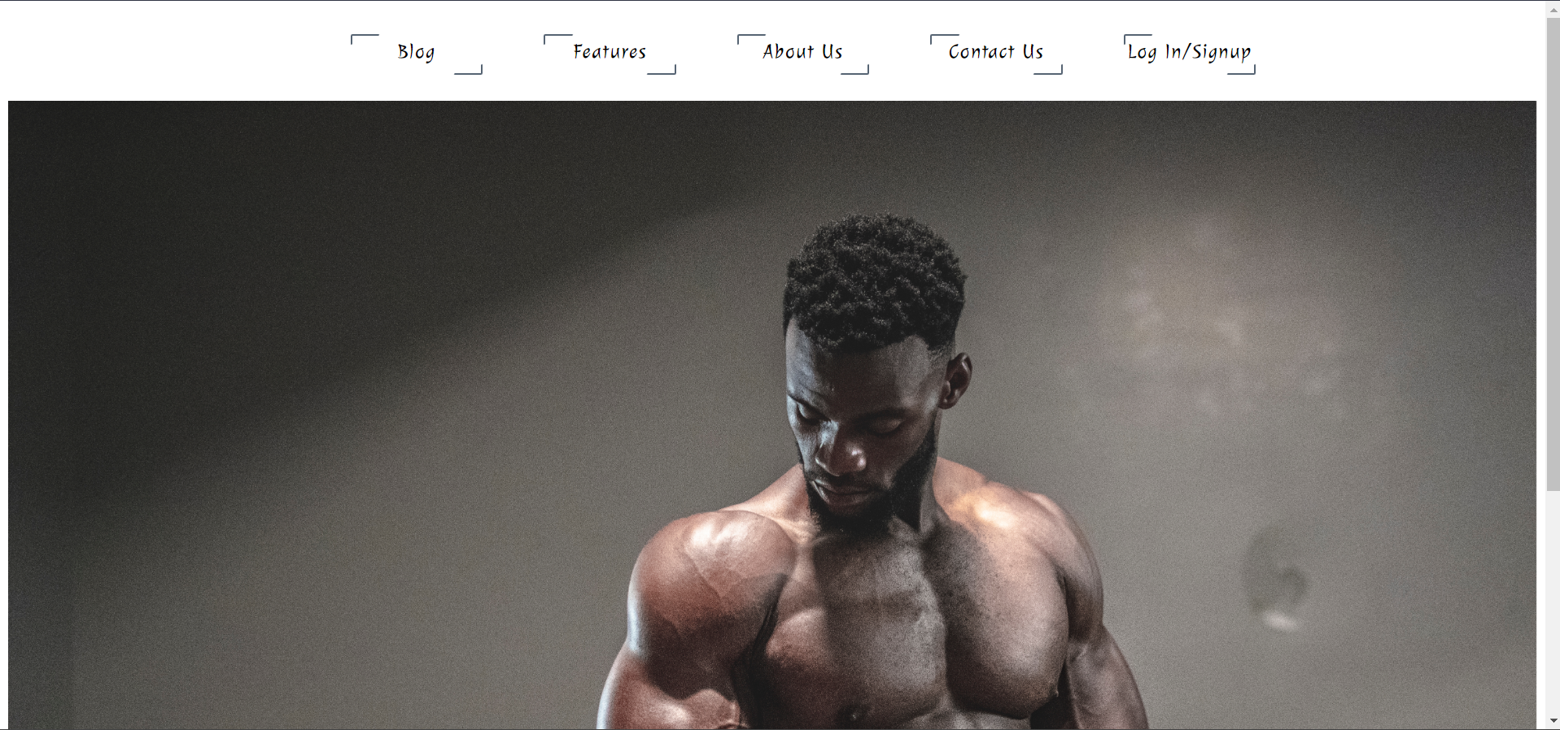

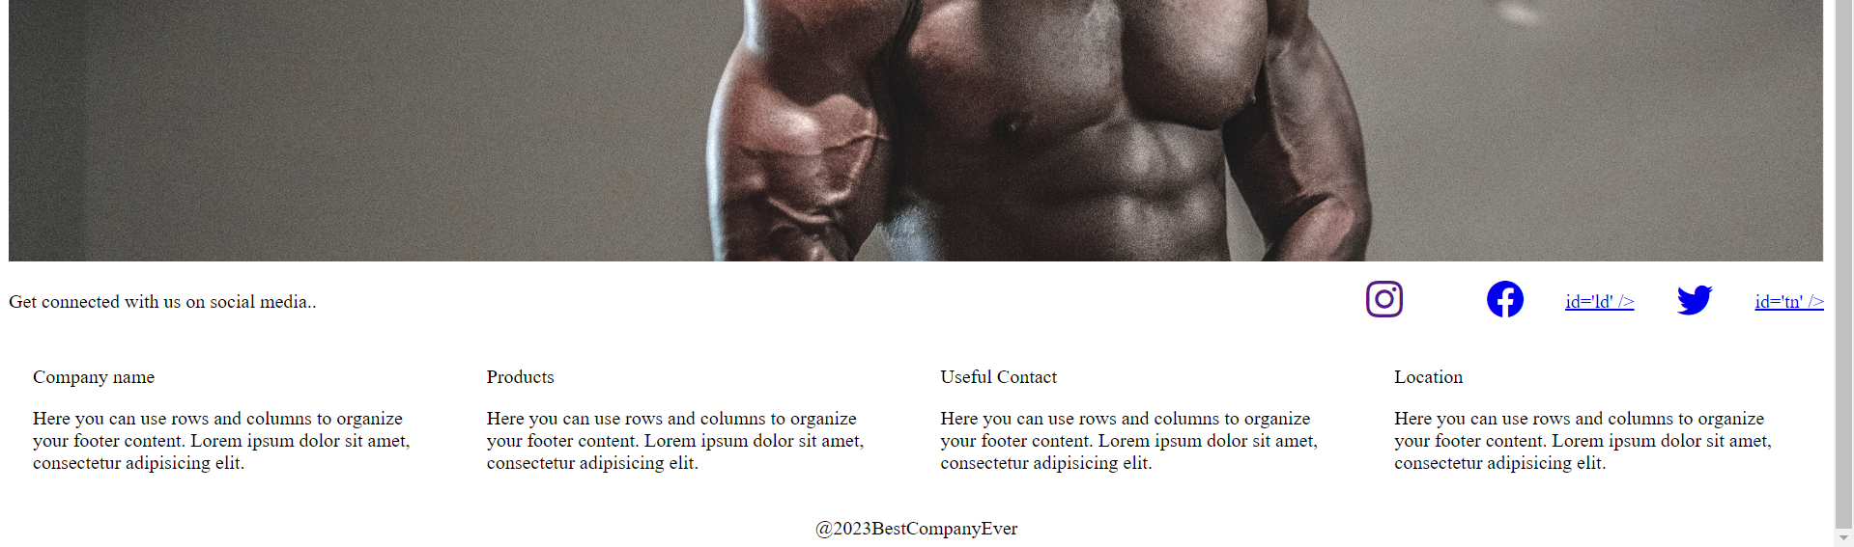

**Outcomes:**

**CO2: Create Web pages using HTML 5 and CSS**

**Questions:**

1. How many axis does a flex-box layout contain?

Ans-: When working with flexbox you need to think in terms of two axes — the main axis and the cross axis. The main axis is defined by the flex-direction property, and the cross axis runs perpendicular to it.

1. What is the difference between auto-fill and auto-fit properties when defining a gridtemplate.

Ans:- When defining a grid layout using CSS Grid, there are two properties that can be used to automatically adjust the size of grid items based on the available space: auto-fill and auto-fit.

The auto-fill property specifies that the grid container should automatically create as many grid tracks (rows or columns) as will fit into the available space. If there is not enough content to fill all of the tracks, empty tracks will be created. The tracks will be sized according to their content, or according to any size constraints specified in the CSS.

1. What is the meaning of the fr unit in the grid layout?

Ans:- The fr unit in CSS Grid layout stands for "fractional unit". It is a flexible length unit that represents a fraction of the available space in the grid container.

The fr unit is commonly used to define the size of grid tracks in relation to each other. For example, if a grid container has two columns, and you want the first column to be twice as wide as the second column,

# Conclusion: (Conclusion to be based on the outcomes achieved)

**We can Conclude that we have learnt about creating flexible content using CSS3.**

# Grade: AA / AB / BB / BC / CC / CD /DD

Signature of faculty in-charge with date

**References:**

**Books/ Journals/ Websites:**

* "HTML5: Black Book", Dreamtech Publication.
* "Web Technologies: Black Book", Dreamtech Publication. ● [http://www.w3schools.com](http://www.w3schools.com/)